学生表

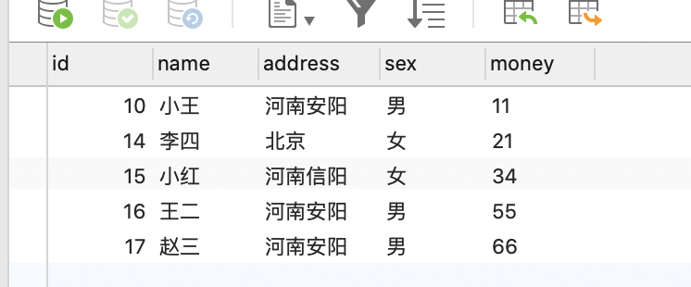

成绩表

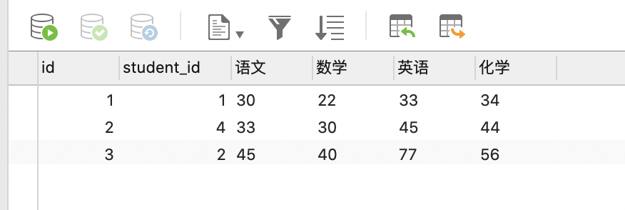

1. 各个地方都有分别几个学生

Select address,count(\*) from student group by address;

1. 各个地方的学生中，每个地方的学生总共有多少钱

Select address,sum(money) from student group by address;

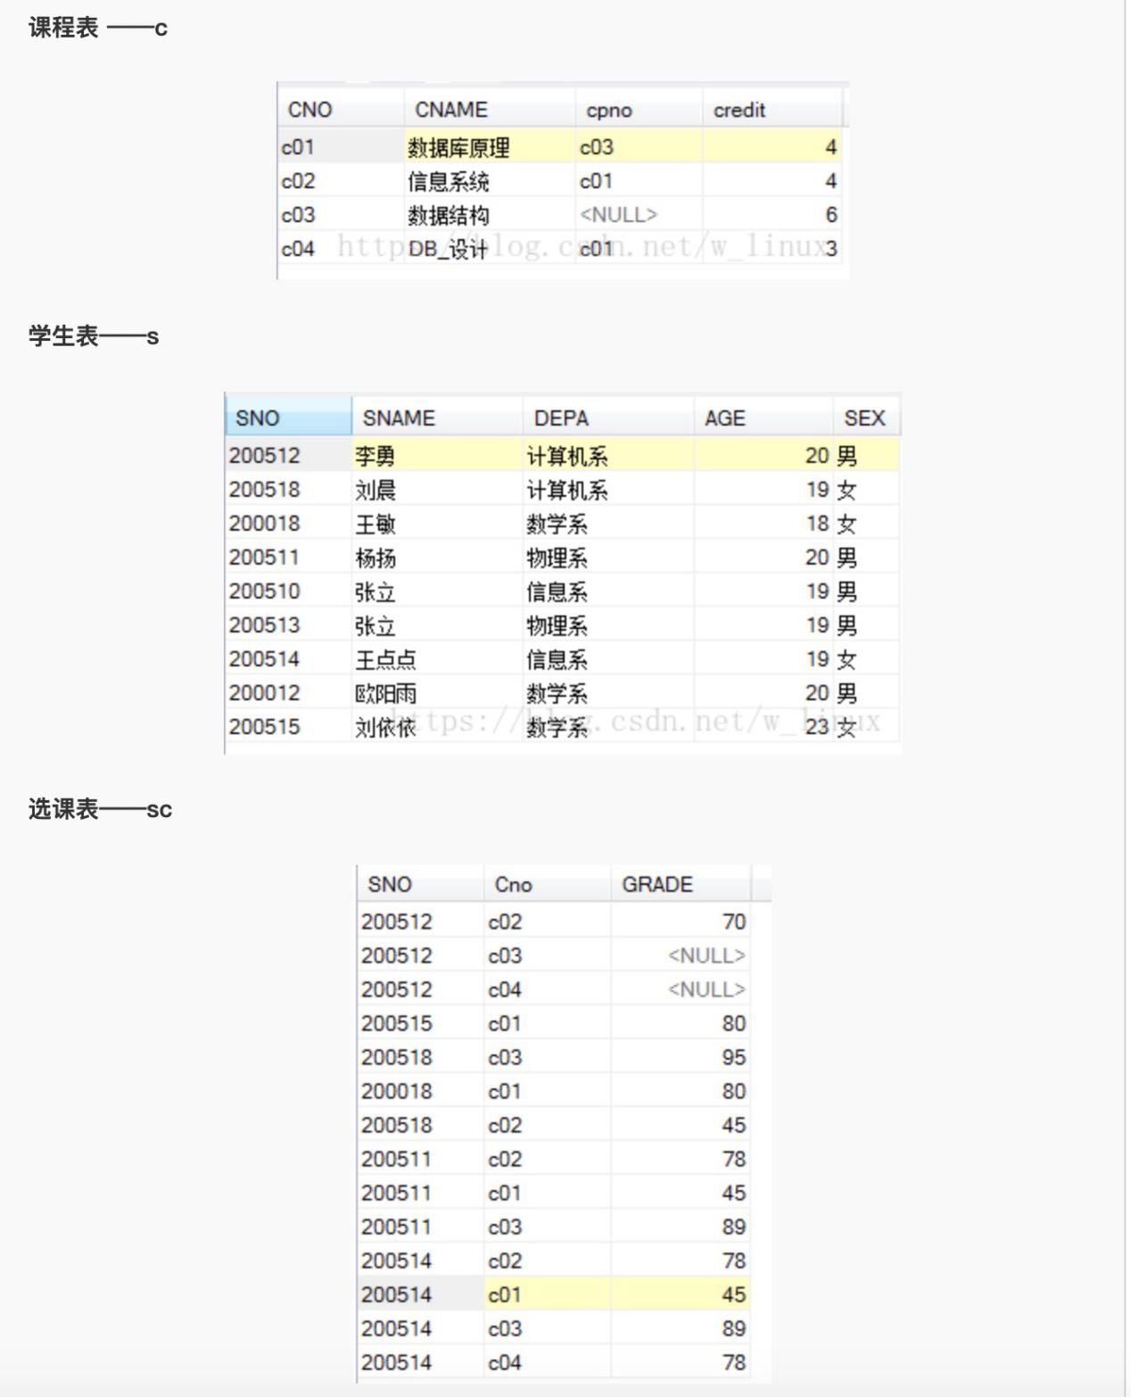

1. #查询选修了课程的学生信息

Select s.\* from s inner join sc on s.sno=sc.sno where sc.cno is not null group by sc.sno;

1. #查询选修“c01” 课程的学生姓名和成绩，并要求对查询结果按成绩的降序排列，如果成绩相同则按学号的升序排列

Select s.sname,sc.grade from s inner join sc on s.sno=sc.sno where sc.cno=’c01’ order by sc.grade desc,sc.sno;

1. 问法一：查询每门课程的平均分

问法二：按课程分组、并对每个课程的成绩求平均分

Select cno,avg(grade) from sc group by cno;

1. #查询选修两门及两门以上课程的学生学号。（根据学号分组，学号分组完成后找到对应的课程记录数大于等于2的学号）

Select sno from sc group by sno having count(\*) >=2;

1. 查询学生201215012选修课程的总学分数

Select sum(credit) from c inner join sc on c.cno=sc.cno where sc.sno=’201215012’;

1. 查询出只选修两门课程的学生学号和姓名

Select s.sno,s.sname from s inner join sc on s.sno=sc.sno group by sc.sno having count(\*) =2;

1. 查询男生、女生分别有多少人

Select sex,count(\*) from s group by sex;

1. 求各个课程号及相应的选课人数

Select cno,count(\*) from sc group by cno;

1. 查询同名同姓学生名单，并统计同名人数

Select sname,count(\*) from s group by name having count(\*)>1;

Select sname,count(\*) from s group by name having count(\*)>=2;

1. 查询不及格的课程名称(课程名称有重复)

Select c.cname from c inner join sc on c.cno=sc.cno where sc.grade<60 group by sc.cno;

Select c.cname from c inner join sc on c.cno=sc.cno group by sc.cno having max(sc.grade) < 60;

1. 检索至少选修两门课程的学生学号

Select sno from sc group by sno having count(\*)>=2;

1. 查询选修了三门以上课程的学生学号

Select sno from sc group by sno having count(\*)>3;

1. 查询平均成绩大于等于90分的学生学号和平均成绩

Select sno,avg(grade) from sc group by sno having avg(grade)>=90;

1. 查询平均成绩大于等于 60 分的同学的学生编号和学生姓名和平均成绩

Select s.sno,s.sname,avg(grade) from s inner join sc on s.sno=sc.sno group by sno having avg(grade)>=60;

1. 查询在 SC 表存在成绩的学生信息

Select s.\* from s inner join sc on s.sno=sc.sno where sc.grade is not null group by sc.sno;

1. 查询所有同学的学生编号、学生姓名、选课总数、所有课程的总成绩(没成绩的显示为 null )-学生表为主 成绩表为辅

Select s.sno,s.sname,count(sc.sno),sum(grade) from s left join sc on s.sno=sc.sno group by sc.sno;

Select s.sno,s.sname,count(sc.sno),sum(grade) from sc right join s on sc.sno=s.sno group by sc.sno;

1. 查有成绩的学生信息

Select s.\* from s inner join sc on s.sno=sc.sno where sc.grade is not null group by sc.sno;

1. 查询各科成绩最高分、最低分和平均分

Select cno,max(grade),min(grade),avg(grade) from sc group by cno;

1. 查询学生姓名和对应总成绩

Select s.sname,sum(grade) from s inner join sc on s.sno=sc.sno group by sc.sno;

1. 查询学生姓名和对应总成绩，成绩为空的学生也要显示出来

Select s.sname,sum(grade) from s left join sc on s.sno=sc.sno group by sc.sno;

Select s.sname,sum(grade) from sc right join s on sc.sno=s.sno group by sc.sno;

创建表stu:

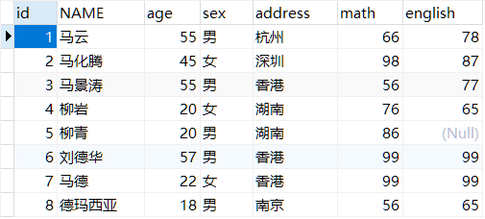

1. 查询各个地区的学生的数量

Select address,count(\*) from stu group by address;

1. 查询各个地区的数学分数在70分以上的学生的数量

Select address,count(\*) from stu where math>70 group by address;

查询各个地区的数学分数都在70分以上的学生的数量

Select address,count(\*) from stu group by address having math>70;

1. 查询学生的姓名及数学分数和总分(姓名有重复)

Select name,math,sum(math+english) from stu group by name;

Select distinct name,math,sum(math+english) from stu ;

1. 查询各个地区的数学分数在70分以上的学生的数量 并且 学生人数大于2人

Select address,count(\*) from stu where math>70 group by address having count(\*) >2;

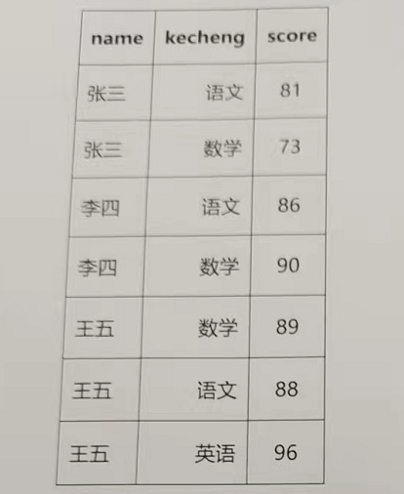

1. 查询student 表每门课都大于80分的学生姓名

Select name from student group by name having min(score)>80;

1. 查询Score表中至少有5名学生选修的并以3开头的课程的平均分数。

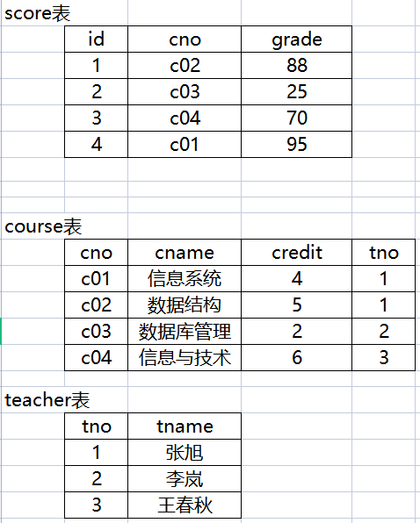

1. 查询“张旭“教师任课的学生成绩。（score表和course表关联字段是cno，course表和teacher表关联字段是tno）

Select score.grade from score inner join course on score.cno=course.cno inner join teacher on course.tno=teacher.tno where teacher.tname=’张旭’;

1. 查询出“计算机系“教师所教课程的成绩表。

Select score.grade from course inner join on score.cno=course.cno;